


ASRTU Arctic School 2022
September, 19-23 online

In order to apply for participation in the online ASRTU Arctic School-2022 please fill in the application form below and attach the following documents:
Thank you!


APPLICATION FORM FOR PARTICIPANTS
First name
Surname
Date of birth
Citizenship
Home university
(full name, country)
Level of education
Year of study
Field of Study
E-mail address
Mobile phone number
What motivates you to participate in the School?

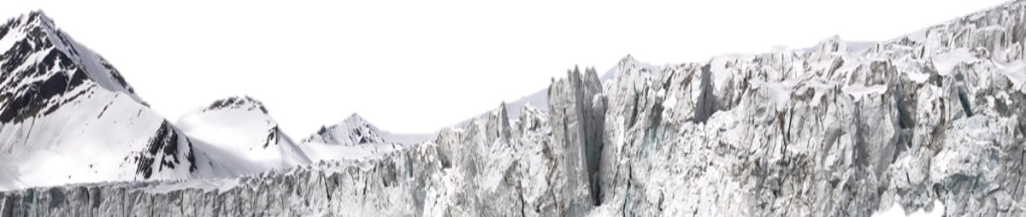
If you have any questions or comments please contact the organizers by e-mail:
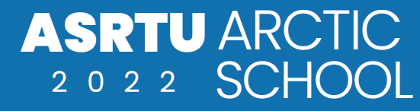
asrtuschool@narfu.ru

